**Lesson01 Tools required in Azure**

**Notes: -**

**1-Visual Studio IDE**

**2-good knowledge on C# and how hosting and development**

**3-Postman, to test API**

**4-WinScp, to connect to FTP server in azure VM**

**5-Putty,**

**Lesson02 Azure Free Account**

**Notes: -**

**1-you need Microsoft account, you get the following**

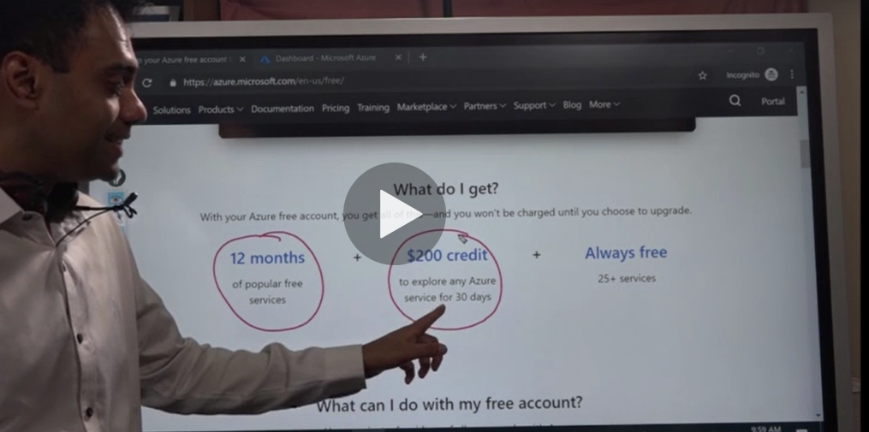

**The free services and for 12 months services**

<https://azure.microsoft.com/en-us/free/free-account-faq/>

**Example:-**

**virtual machine not exceeds 750 hours in months free for 12 months, after that you will charged**

**2-the virtual machine type free is B1S , so any VM above that it will not include in charges**



**Lesson03 Resources && Resource Groups**

**Notes: -**

**1-Resource Group is logical container that hold multiple resources such as VM , SQL Database , etc..**

**2-Resources are the mini part on azure services , such as VM , SQL Database , Storage Account that hold blob storage , file storage , etc..**

**3-you can with resource group hold policies access to resource so any policy applied on the resource group will reflect to all resources**

**4-when you delete resource group it will reflect to all resources**

**Lesson04 Create Resource Group and Resource**

**1-in azure portal > create resource group**

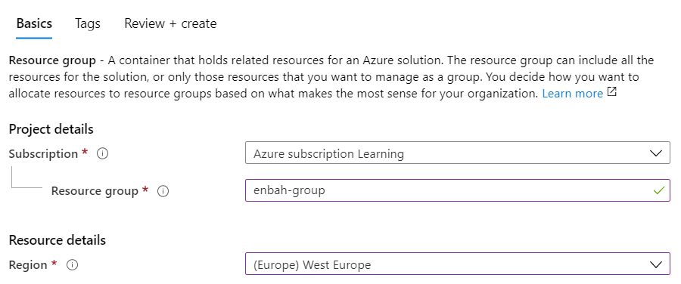

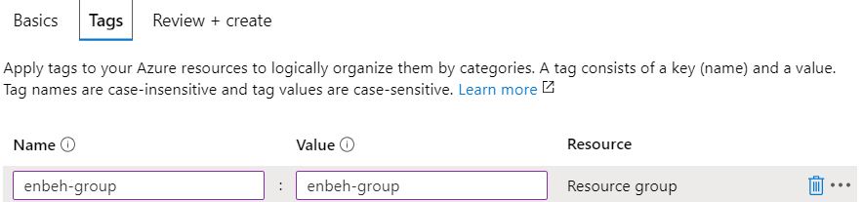

**2-in azure portal > create resource**

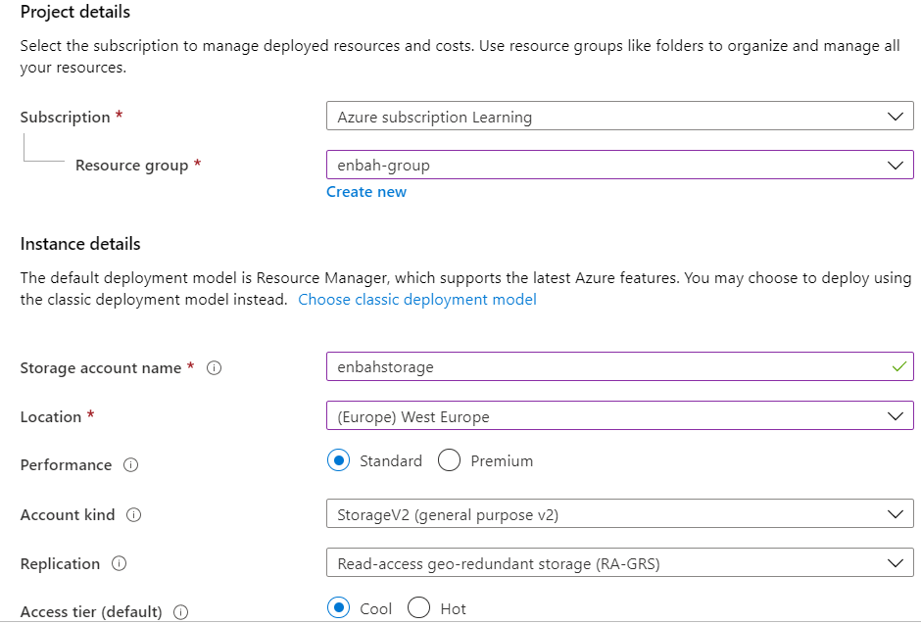

**Lesson05 Azure Monitoring**

**1-on Azure search > type Azure Cost management**

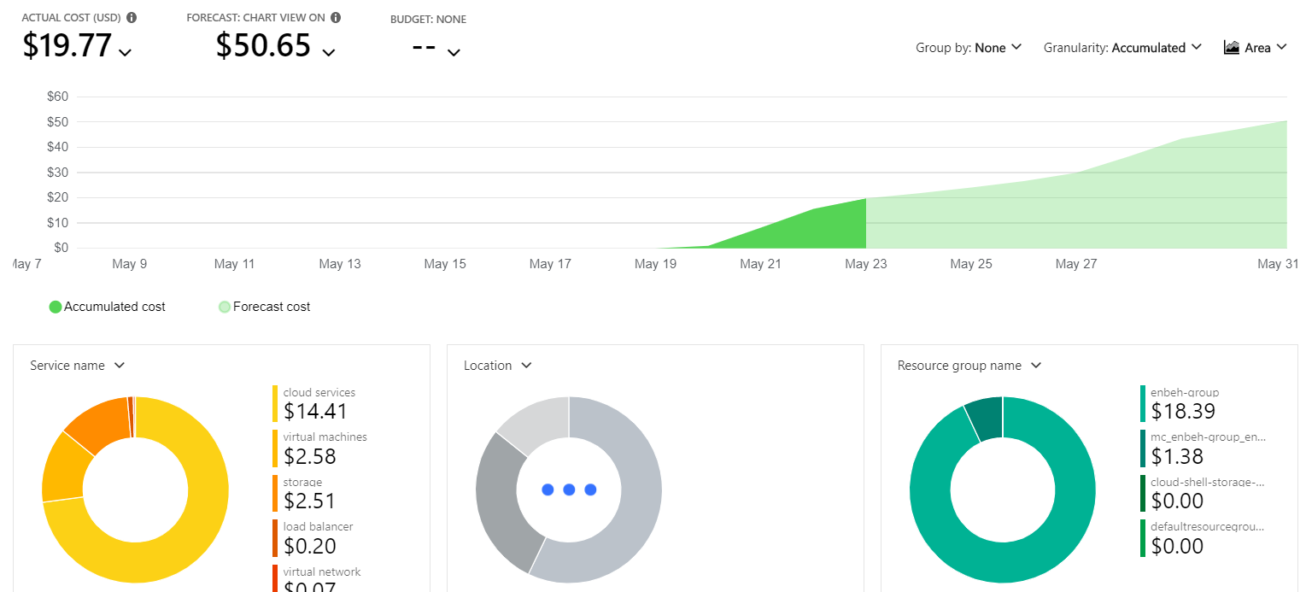

**Lesson06 Azure CLI**

**Steps: -**

**1-on the below URL** [**https://docs.microsoft.com/en-us/cli/azure/install-azure-cli?view=azure-cli-latest**](https://docs.microsoft.com/en-us/cli/azure/install-azure-cli?view=azure-cli-latest) **, you can download and install Azure CLI**

**2-on Azure CLI > type commands**

* **az login //it will open window with login page azure**
* **az storage account list //it will show list of azure storage account**

**[{"accessTier": "Cool",**

**"azureFilesIdentityBasedAuthentication": null,**

**"blobRestoreStatus": null,**

**"creationTime": "2020-05-24T05:46:40.113578+00:00",**

**"customDomain": null,**

**"enableHttpsTrafficOnly": true,**

**"encryption": {**

**"keySource": "Microsoft.Storage",**

**"keyVaultProperties": null,**

**"services": {**

**"blob": {"enabled": true,"keyType": "Account","lastEnabledTime": "2020-05-24T05:46:40.176057+00:00"},**

**"file": {**

**"enabled": true,**

**"keyType": "Account",**

**"lastEnabledTime": "2020-05-24T05:46:40.176057+00:00"},**

**"queue": null,**

**"table": null}},**

**"failoverInProgress": null,**

**"geoReplicationStats": null,**

**"id": "/subscriptions/33bdfb9e-064a-41cf-a348-7918aad8b92a/resourceGroups/enbah-group/providers/Microsoft.Storage/storageAccounts/enbahstorage",**

**"identity": null,**

**"isHnsEnabled": null,**

**"kind": "StorageV2",**

**"largeFileSharesState": null,**

**"lastGeoFailoverTime": null,**

**"location": "westeurope",**

**"name": "enbahstorage",**

**"networkRuleSet": {**

**"bypass": "AzureServices",**

**"defaultAction": "Allow",**

**"ipRules": [],**

**"virtualNetworkRules": []},**

**"primaryEndpoints": {**

**"blob": "https://enbahstorage.blob.core.windows.net/",**

**"dfs": "https://enbahstorage.dfs.core.windows.net/",**

**"file": "https://enbahstorage.file.core.windows.net/",**

**"internetEndpoints": null,**

**"microsoftEndpoints": null,**

**"queue": "https://enbahstorage.queue.core.windows.net/",**

**"table": "https://enbahstorage.table.core.windows.net/",**

**"web": "https://enbahstorage.z6.web.core.windows.net/"},**

**"primaryLocation": "westeurope",**

**"privateEndpointConnections": [],**

**"provisioningState": "Succeeded",**

**"resourceGroup": "enbah-group",**

**"routingPreference": null,**

**"secondaryEndpoints": {**

**"blob": "https://enbahstorage-secondary.blob.core.windows.net/",**

**"dfs": "https://enbahstorage-secondary.dfs.core.windows.net/",**

**"file": null,**

**"internetEndpoints": null,**

**"microsoftEndpoints": null,**

**"queue": "https://enbahstorage-secondary.queue.core.windows.net/",**

**"table": "https://enbahstorage-secondary.table.core.windows.net/",**

**"web": "https://enbahstorage-secondary.z6.web.core.windows.net/"},**

**"secondaryLocation": "northeurope",**

**"sku": {"name": "Standard_RAGRS","tier": "Standard"},**

**"statusOfPrimary": "available",**

**"statusOfSecondary": "available",**

**"tags": {"enbahstorage": "enbahstorage"},**

**"type": "Microsoft.Storage/storageAccounts"}]**